Activity- 1:
Consider the following graph. If there is ever a decision between multiple neighbor nodes in the BFS algorithm, assume we always choose the letter closest to the beginning of the alphabet first. A connected graph with 7 nodes and 7 edges. The edges are undirected and unweight. Distance between two nodes will be measured based on the number of edges separating two vertices. Represent a graph with adjacency list using dictionaries. The keys of the dictionary represent nodes; the values have a list of neighbors.
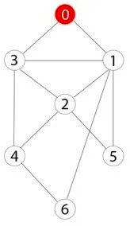

Define function name ‗connected_component‘, this function keep track of all the visited nodes with BFS, is as simple as implementing the steps of the algorithm and assign ‗queue‘ variable already has a node to be checked, i.e., the starting vertex that is used as an entry point to explore the graph. The next step is to implement a loop that keeps cycling until queue is empty. At each iteration of the loop, a node is checked. If this wasn‘t visited already, its neighbors are added to queue. Once the loop is exited, the function (connected_component) returns all of the visited nodes.

Activity- 2:
Apply Breadth First Search on following graph considering the initial state is 1 and final state is
10. Show results in form of open and closed list. Also evaluate it manually.
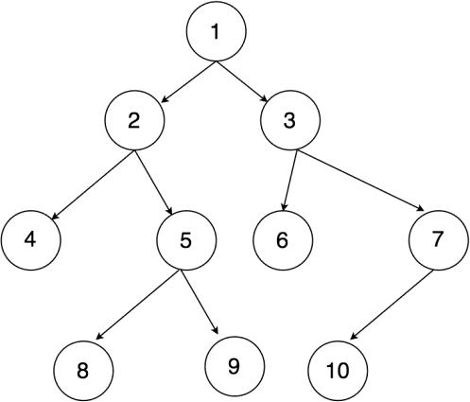

Activity- 3:
Repeat Activity-2, apply BFS by taking initial and final state as user input. Show results in form of open and closed list. Also evaluate it manually.

Activity- 4:
Apply Depth First Search on Activity-2 graph considering the initial state is 1 and final state is
10. Show results in form of open and closed list. Also evaluate it manually.

Activity- 5:
Repeat Activity-4, apply DFS by taking initial and final state as user input. Show results in form of open and closed list. Also evaluate it manually.

Activity- 6:
Represent a graph with adjacency list using dictionaries. The keys of the dictionary represent nodes; the values have a list of neighbors. Apply Breadth First Search on following graph considering the initial state is A and final state is K. Also evaluate it manually.
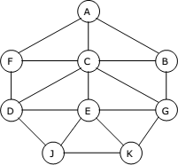

Activity- 7:
Represent a graph with adjacency list using dictionaries. The keys of the dictionary represent nodes; the values have a list of neighbors. Apply Depth First Search on Activity-6 graph considering the initial state is A and final state is K. Also evaluate it manually.

